

User guide: Cultural Humility Framework

**Improving healthcare experiences and outcomes for First Nations Peoples accessing Western health services**

Murray PHN acknowledges its catchment crosses over many unceded  
 First Nations Countries following the Dhelkunya Yaluk (Healing River).

We pay our respects and give thanks to the Ancestors, Elders and   
Young People for their nurturing, protection and caregiving of these sacred   
lands and waterways, acknowledging their continuation of cultural, spiritual  
 and educational practices.

We are grateful for the sharing of Country and the renewal that Country gives us.

We acknowledge and express our sorrow that this sharing has come at a personal, spiritual and cultural cost to the wellbeing of First Nations Peoples.

We commit to addressing the injustices of colonisation across our   
catchment, and to listening to the wisdom of First Nations communities  
who hold the knowledge to enable healing.

We extend that respect to all Aboriginal and Torres Strait Islander Peoples.

*We aspire to be an anti-racist organisation, embedding cultural humility as a daily practice,   
to improve health outcomes and health equity in our communities. We recognise cultural humility as a life-long commitment to self-reflection, personal growth and redressing   
power imbalances in our society.*

Prepared in partnership with Murray PHN by  
Dr Shirley Godwin (Badimaya Yamatji, she/her), Guwanda Education

**August 2024**

*Acknowledgement of artist and artwork

***(***

***Healing River in the Dja Dja Wurrung language***

My name is Madison Connors (nee Saunders), and I am a Dja Dja Wurrung, Yorta Yorta and Kamilaroi woman. I am a descendant of Henry ‘Harmony’ Nelson who was known to many.

For many centuries, my people have connected with the land and immersed themselves in the healing properties it provides. Our connection to Country is our bloodline. Being connected offers a holistic approach to our health and wellbeing, connecting our spiritual being with our physical being.

This artwork draws on my Dja Dja Wurrung heritage and reflects the landscape of my ancestors’ Country. Its focal point is the Murray River, whose flowing waters bind the various elements of the landscape together. The mountains, the rock formations and the wildlife hold strength and resilience and remind us to continue the fight for what is right for our people, while the endangered turtle - like our culture - needs preservation.

The central circle portrays the strength of the community coming together around a campsite, uniting and sharing the knowledge that is kept in our hearts as the essence of our own identity and journey. The leaves extending from the centre represent bushland, where the trees that hold all of our stories and memories touch the sky. They reach to the ancestors while their roots are embedded in the soil we continue to walk on, helping us to follow in the footsteps of our ancestors and our elders.

I take off my shoes and ground myself with the earth, reminding me where I have come from. If we look after the land, the land will be sure to look after us.

*Artwork and story by   
Madison Connors (Dja Dja Wurrung, Yorta Yorta, Kamilaroi)*

# Terminology

## The terms ‘First Nations’, ‘Aboriginal and Torres Strait Islander’ and ‘Indigenous’ are used interchangeably to privilege ways of identifying that are self-determined. First Nations is the predominant term used in the framework to communicate diversity and sovereignty.

## It is acknowledged that there is not one preferred term to represent Aboriginal and Torres Strait Islander Peoples living in Australia, nor does any one term adequately represent the immense diversity of cultural ways of being across sovereign nations.

Contents

About the user guide 6

Key Element 1: Governance 7

Focus areas 8

Reflective questions 8

Examples of evidence 9

Recommended resources 10

Key Element 2: Partnerships 10

Focus areas 10

Reflective questions 10

Examples of evidence 11

Recommended resources 11

Key Element 3: Workforce 12

Focus areas 12

Reflective questions 12

Examples of evidence 13

Recommended resources 14

Key Element 4: Inclusive care 15

Focus areas 15

Reflective questions 15

Examples of evidence 16

Recommended resources 16

Appendix A: Culturally-informed care 34

Social and Emotional Wellbeing: An Aboriginal and Torres Strait Islander Perspective 35

Appendix B: Bibliography 36

About the user guide

Priority Reform Three of the National Agreement on Closing the Gap (the National Agreement) requires the systemic and structural transformation of mainstream agencies. This reform compels Western health services to implement targeted strategies aimed at eliminating racism, embedding Cultural Safety, improving Community engagement and partnerships, enabling funding transparency and accountability, and centring Aboriginal and Torres Strait Islander cultures[1]. Murray PHN’s commitment to driving the transformation necessitated in the National Agreement led to the development of a Cultural Humility Framework (CHF) designed to build the capacity of the local primary health workforce to work in partnership with First Nations Peoples to deliver culturally informed, responsive and safe services, free of racism.

The Murray PHN CHF provides principles and measurable actions for ongoing improvement in Western health services to better meet the needs of First Nations Communities and service users across its catchment. This accompanying document, the Cultural Humility Framework User Guide, supports the practical application of the CHF by providing guidance for the planning and implementation of targeted strategies.

# The user guide has two parts:

**Part 1** provides reflection questions, examples of evidence and additional recommended resources to support a strategic approach to operationalising each key element of the CHF.

**Part 2** is a self-assessment tool to assist health services to appraise and track their progress towards best practice in service delivery as guided by the CHF.

This user guide should be used in conjunction with the CHF, particularly in relation to building a shared understanding of guiding principles, core concepts and the interrelatedness of all aspects of the framework.

*Figure 1: Murray PHN’s   
Cultural Humility Framework*

PART 1: A STRATEGIC APPROACH

Achieving the sustainable systemic change required to deliver services that best meet the needs of First Nations Communities demands a strategic approach encompassing a commitment to ongoing critical reflection and learning. This section of the user guide supports Western health services to reflect, learn and plan progressing cultural humility and culturally responsive and safe ways of working with and for First Nations service users and local Communities.

To begin with, on both personal and organisational levels, health service staff need to turn the gaze inwards and consider:

* Where are they currently positioned in their cultural humility journey?
* Where do they need to be to meaningfully meet the needs of First Nations Communities?
* How well can existing capabilities, resources and opportunities support progress?
* What additional capabilities, resources and opportunities are needed to enable progress?
* What current personal and organisational ways of thinking and working potentially hinder progress and how can these be addressed?

For each of the key elements of the CHF, this section provides:

**Reflection questions:** to support critical analysis of current ways of thinking and working, and envisioning news ways of doing business that effect transformative change.

**Examples of evidence:** to support planning towards practical actions and outcomes by illustrating what each key element might look like in practice. The examples provided are suggestions only and the lists are not exhaustive; specific organisational contexts will determine the most applicable way to demonstrate the implementation of strategies.

**Recommended resources:** to support ongoing learning from the knowledge and evidence that already exists. These resources represent First Nations led or co-led strategies, plans and guiding frameworks designed to drive systemic reform across the health system.

*Figure 2. Key elements of the Cultural Humility Framework*

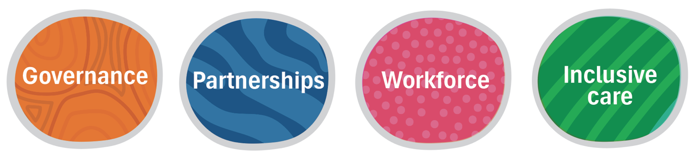

Key Element 1: Governance

Governance structures and mechanisms support a whole-of-organisation approach to embedding cultural humility in all aspects of core business.

# Focus areas

* **Leadership:** Those in organisational and team leadership positions noticeably demonstrate culturally responsive and safe knowledge, attitudes, behaviours and actions.
* **Governing documents:** A commitment to addressing First Nations health inequity through the provision of culturally responsive and safe service delivery is made visible in organisational governing documents.
* **Policy and practices:** A whole-of-organisation approach to addressing First Nations health inequity through the provision of culturally responsive and safe service delivery is embedded across organisational policies and practices.
* **Resources:** Adequate, appropriate and sustainable resources are allocated for initiatives to meet the needs and improve the experiences of service users.
* **Monitoring and evaluation:** Mechanisms to monitor and evaluate outcomes of strategies, including the identification of barriers and enablers for success are embedded across the organisation to inform continuous quality improvement processes.
* **Data management:** Data is collected, processed and shared in ways that uphold the principles of Cultural Safety and Indigenous data sovereignty and governance.

# Reflective questions

* How prepared are those in leadership roles to assess and develop their own cultural capabilities, and what capacity and opportunities do they have to support increased cultural capabilities across all levels of the organisation?
* How prepared are those in leadership roles to initiate and drive change, and what capacity and opportunities do they have to foster a shared sense of ownership of change across all levels of the organisation?
* What opportunities and resources currently exist to identify and strengthen enablers for embedding change and are they sustainable?
* What opportunities and resources currently exist to identify and address barriers to embedding change, and how can they be strengthened?
* How does the organisation identify, appraise and advance policies and practices related to service delivery to First Nations services users?
* How does the organisation determine and appraise the appropriate level of workforce and budgetary resources needed to support culturally responsive and safe service delivery?
* How does the organisation support First Nations self-determination? Do current governing and decision-making processes empower First Nations Peoples to provide leadership in relation to services that impact their local Communities?
* Do current mechanisms for the collection, monitoring and evaluation of data reflect an understanding of the principles of Cultural Safety and Indigenous data sovereignty and governance? How can the organisation improve working knowledge and application of these principles?

# Examples of evidence

* Records showing participation in formal cultural training tailored for executive/management. This could include professional development activities focused on cultural governance, creating culturally safe workplaces and organisational anti-racism training
* Documented agenda items, meeting minutes and actions related to building organisational capacity to deliver culturally responsive and safe care
* Publicly accessible/visible documented Statements of Commitments, for example:
* To meeting obligations for improving health inequity through culturally responsive and safe service delivery
* To acknowledging and addressing the ongoing impacts of colonisation through truth-telling and self-determination
* To clients’ rights to culturally safe care and redress for practice identified as culturally unsafe
* Documented circulation/promotion of calendars of local cultural events and dates of significance, and documented evidence the organisation organises and/or participates in cultural celebrations/ commemorations. Participation in local events is included in workload allocation and performance review policies and processes
* Commitments to addressing health inequity and racism through culturally responsive and safe service delivery are included in governing documents, for example:
* Organisational values and vision statements
* Strategic and business plans
* Organisation constitution
* Employee charter and Code of conduct
* Reconciliation Action Plan
* Documented meeting dates, minutes and actions evidencing collaboration with local First Nations Peoples, organisations or Communities for governing, planning, design and delivery of services
* Initiatives related to the provision of culturally responsive and safe service delivery are included in organisational policies and strategies, for example:
* First Nations engagement strategy
* First Nations procurement policy
* First Nations employment strategy
* Cultural safety action plan
* HR policies and procedures
* Clinical policies and procedures
* Monitoring, evaluation, and quality improvement policies and procedures
* Documented working knowledge and implementation of First Nations-led culturally safe evaluation frameworks
* Documented working knowledge and implementation of the Framework for Governance of Indigenous Data[2]
* Adequate, appropriate and sustainable investment is evidenced by line items in relevant budgets.

# Recommended resources

* [Cultural Respect Framework 2016-2026: For Aboriginal and Torres Strait Islander Health – A National approach to building a culturally respectful health system](https://nacchocommunique.com/wp-content/uploads/2016/12/cultural_respect_framework_1december2016_1.pdf) Australian Health Ministers’ Advisory Council’s National Aboriginal and Torres Strait Islander Health Standing Committee, 2016

**Domain 1:** Whole-of-organisation approach and commitment - Systemic approaches to cultural responsiveness and safety are reflected across governance, leadership, investment, policy and accountability

* [Victorian Government Self-Determination Reform Framework](https://www.firstpeoplesrelations.vic.gov.au/sites/default/files/2019-09/Self-Determination-Reform-Framework-August-2019.PDF) State of Victoria, 2019
* [National Safety and Quality Health Service Standards User Guide for Aboriginal and Torres Strait Islander health](https://www.safetyandquality.gov.au/sites/default/files/migrated/National-Safety-and-Quality-Health-Service-Standards-User-Guide-for-Aboriginal-and-Torres-Strait-Islander-Health.pdf). Wardliparingga Aboriginal Research Unit, Australian Commission on Safety and Quality in Health Care, 2017.

Key Element 2: Partnerships

The organisation embeds a commitment to privileging the voices of First Nations Peoples through mechanisms that enable respectful, mutually beneficial and self-determined collaborative partnerships with local Communities.

# Focus areas

* **Understanding Community:** An understanding of demographic, health and cultural contexts of local Communities underpins targeted improvements in hearing and meeting the needs of service users
* **Community collaboration:** The critical role of respectful, mutually beneficial and self-determined collaborative partnerships in meeting Community needs is recognised and reflected in organisational ways of working
* **Consumer participation:** The voices of those who use the service are empowered and prioritised to inform organisational ways of working
* **Feedback:** Organisations are culturally responsive in actively, adequately and accurately collecting and responding to feedback from service users and local Communities.

# Reflective questions

* How is knowledge of the local Community reflected in organisational ways of working? What further opportunities can be created to demonstrate an understanding of the demographic, health and cultural contexts of local Communities to inform operational business?
* How does the organisation know what the local Community’s priorities, needs and aspirations are? What opportunities exist or can be created to build this knowledge? How are placed-based approaches embedded in service delivery to local Communities?
* What is the level of knowledge and observation of local Community protocols, and how are these communicated and supported across all levels of the organisation?
* How are the voices of the local Community prioritised and incorporated into organisational ways of working related to delivery of services to First Nations service users? How can this be strengthened?
* How are the strengths of the local Community recognised and how are strength-based approaches reflected in organisational ways of working?
* How well are the principles of Indigenous cultural governance understood and reflected in the way the organisation engages with the local Community?
* How are collaborative partnerships with local Communities currently facilitated and what opportunities exist for strengthening these relationships? What mechanisms are in place to ensure current and future partnerships support self-determination and reciprocity? How are power imbalances in partnerships acknowledged and addressed?
* How does the organisation collect and act on feedback from services users and the local Community, and how does the organisation ensure these processes are culturally safe? Are these processes and outcomes communicated to the local Community?
* Do processes for managing service user feedback data uphold the principles of Indigenous data sovereignty and governance?
* What processes are in place for services users and the local Community to call attention to racism and culturally unsafe practices, and how are these concerns managed and the outcomes communicated?

# Examples of evidence

* Documented participation in cultural training developed and delivered by local First Nations Peoples and Communities
* Display of locally commissioned artwork, health educational material and promotion of local Community events and achievements
* Inclusion of locally commissioned artwork, health educational material and promotion of local Community events and achievements in organisational documents and public communications e.g. newsletters
* Memorandums of Understanding, or alternative formal written agreements with local ACCHOs or other relevant Community-led organisations
* Letters of support from local Community organisations for programs and services
* Funding agreements with local Community organisations that reflect self-determination and power equity
* Representation from the local First Nations Community on the Board, Executive Committee and program leadership groups
* Establishment of a First Nations Reference Group, Community Advisory Committee, Elders Council or First Nations Working Parties, with Terms of Reference, and dates, minutes and documented outcomes of meetings
* Mechanisms for respectful Community engagement are included in organisational policies and strategies, for example:
* First Nations community engagement protocol
* First Nations self-determination framework
* Consumer feedback policy
* A cultural safety action plan that reflects collaboration with local Communities.
* Evidence that Patient Reported Measures (PRMs) are informed by and reflect First Nations worldviews, values and preferences, and the principles of Indigenous data sovereignty and governance are demonstrated in the way data is managed
* Documentation of culturally safe processes for collecting service user feedback, and evidence of how actions are taken in response, and then communicated and shared with local Communities.

# Recommended resources

* [Cultural Respect Framework 2016-2026: For Aboriginal and Torres Strait Islander Health – A National approach to building a culturally respectful health system](https://nacchocommunique.com/wp-content/uploads/2016/12/cultural_respect_framework_1december2016_1.pdf) Australian Health Ministers’ Advisory Council’s National Aboriginal and Torres Strait Islander Health Standing Committee, 2016

**Domain 4: Consumer participation and Engagement** - Healthcare and health services and systems are informed by active and meaningful partnerships and engagement with Aboriginal and Torres Strait Islander health consumers, families and Communities

**Domain 5: Stakeholder partnerships and collaboration** - Respectful and effective partnerships and collaboration between Aboriginal and Torres Strait Islander stakeholders and healthcare providers is a key element to supporting accessible, responsive and culturally safe services

* [National Safety and Quality Health Service Standards User Guide for Aboriginal and Torres Strait Islander health](https://www.safetyandquality.gov.au/sites/default/files/migrated/National-Safety-and-Quality-Health-Service-Standards-User-Guide-for-Aboriginal-and-Torres-Strait-Islander-Health.pdf). Wardliparingga Aboriginal Research Unit, Australian Commission on Safety and Quality in Health Care, 2017

**Action 2.13:** The health service organisation works in partnership with Aboriginal and Torres Strait Islander Communities to meet their healthcare needs

* Aboriginal and/or Torres Strait Islander cultural capability toolkit, Victorian Public Sector Commission, 2022
* [Aboriginal and Torres Strait Islander protocols](https://vpsc.vic.gov.au/workforce-programs/aboriginal-cultural-capability-toolkit/aboriginal-protocols/)
* [Aboriginal and Torres Strait Islander self-determination](https://vpsc.vic.gov.au/workforce-programs/aboriginal-cultural-capability-toolkit/aboriginal-self-determination/)
* [National Aboriginal and Torres Strait Islander Health Plan 2021-2031](https://www.health.gov.au/resources/publications/national-aboriginal-and-torres-strait-islander-health-plan-2021-2031). Commonwealth of Australia, 2021

**Priority 1:** **Genuine shared decision-making and partnerships**: shared decision-making, shared partnerships and collaborative cross-sector approaches – including through Community-led and nation building approaches and structural reform – operate across all levels of health planning and services delivery, including mainstream services

* [Korin Korin Balit-Djak Aboriginal health, wellbeing and safety strategic plan 2017-2027](https://www.health.vic.gov.au/health-strategies/korin-korin-balit-djak-aboriginal-health-wellbeing-and-safety-strategic-plan-2017). State of Victoria, 2017

**Priority Focus 3.3: Aboriginal leadership in governance and accountability**: Aboriginal Communities should not only be involved in the design, development and delivery of health and human services, they also need to have their voice and experience heard in the oversight of governance, monitoring and evaluation.

Key Element 3: Workforce

The crucial role of a culturally capable health workforce, including First Nations Peoples employed across all areas of service delivery, in meeting the needs of local Communities is reflected in organisational policy and practice.

# Focus areas

* **First Nations employees:** Valuing and building a strong First Nations workforce is prioritised through developing culturally responsive recruitment and creating culturally safe workplaces
* **Non-First Nations employees:** Building the cultural capacities of all non-First Nations employees to work in culturally responsive ways with colleagues, service users and Communities is valued and strategically prioritised

# Reflective questions

* How many First Nations Peoples are employed across the organisation, and does this include clinical and non-clinical roles and leadership positions?
* Does the organisation have a commitment to increasing and empowering its First Nation workforce, and how is this articulated in strategic and policy documents?
* How does the organisation value the knowledge and skills First Nations staff bring to all areas of the organisation? What opportunities can be created to build First Nations leadership and increase the impact of First Nations knowledges and skills across relevant programs?
* How does the organisation ensure a culturally safe and respectful workplace for its First Nations staff, and is this informed by First Nations input? How can the organisation increase its understanding of what a culturally safe workplace looks like?
* What mechanisms are in place to understand, identify and address workplace racism, and how are these informed by the experiences of First Nations staff?
* How is the cultural and colonial load of First Nations employees understood, validated and addressed?
* Has the organisation experienced difficulties in recruiting First Nations staff and, if yes, are there processes in place to build an understanding of the reasons for this? Are First Nations Peoples involved in recruitment and selection processes?
* What is the extent of First Nations staff turnover and, if high, are there processes in place to build an understanding of the reasons for this?
* Is there an awareness and working knowledge of existing national and state frameworks designed to guide development of culturally responsive recruitment, selection, induction and employee support processes? How can input from local Communities tailor this guidance to local contexts?
* Does the organisation recognise and support the diverse cultural needs of individual First Nations staff members, and how are individual staff empowered to express these needs?
* How are non-First Nations staff supported to reflect on and build both their own and the organisation’s capacity to work in culturally responsive and safe ways?
* How is participation in cultural training and the delivery of culturally responsive service recognised and rewarded?
* How is the level of understanding about racism within the organisation assessed and increased, and how are staff supported to embed anti-racism approaches in their work roles? Does this include an understanding of how power, privilege and bias impact individual and organisational ways of working?

# Examples of evidence

* Records indicating the number of First Nations employees, positions held, staff turnover and recruitment efforts
* Meeting dates, agenda items and minutes of discussions related to building and valuing a First Nations workforce
* Strategic and policy documents demonstrating a commitment to building and valuing a First Nations workforce
* A First Nations employment strategy outlining recruitment, selection, induction and support processes that have been guided by First Nations Peoples
* A cultural safety plan which includes strategies for creating and maintaining a culturally safe and racism-free workplace
* A detailed cultural training plan for non-First Nations staff, including anti-racism training and records of participation, policy evidence of mandatory and ongoing training
* Documentation related to the inclusion of cultural training in workload allocation and performance review processes. Cultural training is stipulated as a criterion in promotion processes
* Recruitment processes for non-First Nations staff, including selection criteria, that stipulate a requirement for working in culturally responsive and safe ways.

# Recommended resources

* [National Aboriginal and Torres Strait Islander Health Workforce Strategic Framework and Implementation Plan 2021–2031](https://www.health.gov.au/sites/default/files/documents/2022/03/national-aboriginal-and-torres-strait-islander-health-workforce-strategic-framework-and-implementation-plan-2021-2031.pdf). Commonwealth of Australia, 2022
* [Aboriginal Workforce Strategy 2021 – 2026](https://www.dffh.vic.gov.au/sites/default/files/documents/202109/DH%20and%20DFFH%20Aboriginal%20Workforce%20Strategy%202021%E2%80%932026%20v2.pdf) State of Victoria, Department of Health and Department of Families, Fairness and Housing, 2021
* [Cultural Respect Framework 2016-2026: For Aboriginal and Torres Strait Islander Health – A National approach to building a culturally respectful health system](https://nacchocommunique.com/wp-content/uploads/2016/12/cultural_respect_framework_1december2016_1.pdf) Australian Health Ministers’ Advisory Council’s National Aboriginal and Torres Strait Islander Health Standing Committee, 2016

**Domain 3: Workforce development and training:** Health services and organisational culture support and promote building a workforce that is appropriately skilled, supported and resourced to influence and provide accessible, culturally responsive and safe services for Aboriginal and Torres Strait Islander people and Communities

* [National Safety and Quality Health Service Standards User Guide for Aboriginal and Torres Strait Islander health](https://www.safetyandquality.gov.au/sites/default/files/migrated/National-Safety-and-Quality-Health-Service-Standards-User-Guide-for-Aboriginal-and-Torres-Strait-Islander-Health.pdf). Wardliparingga Aboriginal Research Unit, Australian Commission on Safety and Quality in Health Care, 2017

**Action 1.21:** The health service organisation has strategies to improve the cultural awareness and cultural competency of the workforce to meet the needs of its Aboriginal and Torres Strait Islander patients

* Aboriginal and/or Torres Strait Islander cultural capability toolkit, Victorian Public Sector Commission, 2022
* [Recruiting Aboriginal and/or Torres Strait Islander staff](https://vpsc.vic.gov.au/workforce-programs/aboriginal-cultural-capability-toolkit/recruiting-aboriginal-staff/)
* [Inducting and welcoming Aboriginal and/or Torres Strait Islander staff](https://vpsc.vic.gov.au/workforce-programs/aboriginal-cultural-capability-toolkit/inducting-and-welcoming-aboriginal-staff/)
* [Supporting Aboriginal and/or Torres Strait Islander staff](https://vpsc.vic.gov.au/workforce-programs/aboriginal-cultural-capability-toolkit/supporting-aboriginal-staff/)
* [National Aboriginal and Torres Strait Islander Health Plan 2021-2031](https://www.health.gov.au/resources/publications/national-aboriginal-and-torres-strait-islander-health-plan-2021-2031). Commonwealth of Australia, 2021

**Priority 3 Workforce**: Aboriginal and Torres Strait Islander representation and leadership is prioritised across the health, disability and aged care workforces. These workforces are grown and sustained across all health services, including mainstream services. Personal and professional development is prioritised and available to all Aboriginal and Torres Strait Islander workers across the health system

* [Korin Korin Balit-Djak Aboriginal health, wellbeing and safety strategic plan 2017-2027](https://www.health.vic.gov.au/health-strategies/korin-korin-balit-djak-aboriginal-health-wellbeing-and-safety-strategic-plan-2017). State of Victoria, 2017

**Priority Focus 3.2**: A strong and sustainable Aboriginal workforce: The Aboriginal workforce is skilled, responsive and resilient. Investing in the Aboriginal workforce is an investment in the health, wellbeing and safety of Victoria’s Aboriginal people and Communities

* [Cultural safety in Australia Discussion paper](https://www.lowitja.org.au/wp-content/uploads/2024/08/CulturalSafetyinAustralia_DiscussionPaper_August2024.pdf). Mohamed, J, Stacey, K, Chamberlain, C & Priest Lowitja Institute, 2024
* [Gari Yala (Speak the Truth): Centreing the experiences of Aboriginal and/or Torres Strait Islander Australians at work](https://www.dca.org.au/research/gari-yala-speak-truth), Jumbunna Institute for Indigenous Education and Research and Diversity Council of Australia, 2020
* [Aboriginal and Torres Strait Islander Peoples – Leading Practice](https://www.dca.org.au/resources/aboriginal-and-torres-strait-islander-peoples/aboriginal-and-torres-strait-islander-peoples-leading-practice), Diversity Council of Australia, 2023

Key Element 4: Inclusive care

An organisational commitment to improving the experiences of and outcomes for First Nations service users through the delivery of culturally informed, responsive and safe care is incorporated into policy and practice.

# Focus areas

* **Understanding needs:** All employees providing care and services have a well-developed understanding and working knowledge of the individual, Community and population level health considerations for First Nations Peoples
* **Welcoming environment:** The service provider creates and maintains culturally responsive and welcoming spaces that reflect First Nations cultural values, practices and needs
* **Identification:** Processes are in place for accurate identification of First Nations service users and information is collected and managed in culturally responsive and safe ways
* **Communication:** The organisation recognises that culturally responsive communication is the foundation for the delivery of care judged by First Nations Peoples as safe to approach and use
* **Holistic care:** The care/service provided incorporates holistic understandings of the determinants of health and wellbeing, tailored to the service user’s needs, preferences and desired outcomes.

# Reflective questions

* How well are the health status, needs and priorities of the local First Nations population(s) understood and reflected in the organisation’s models of care and service delivery?
* How does the organisation keep up-to-date with current evidence and available supports and programs for improving local health outcomes?
* How much consideration has been put into how well the organisation creates a welcoming environment? Has this incorporated physical (design, layout, and appearance), emotional (the feeling of being supported and cared) and relational (the quality of relationships within the workforce and with services users) aspects of the clinical environment?
* How can First Nations direction be sought for planning and implementing an enhanced culturally responsive and welcoming health service environment?
* How does the organisation acknowledge the significance of cultural determinants of health, including the importance of Country, both publicly and in internal policies and practices?
* How does the organisation ensure culturally safe and racism-free interactions between staff, including clinicians, and services users? How does the organisation determine if service users experience the delivery of care as culturally safe?
* Which mechanisms are in place to ensure the collection and recording of the Aboriginal and Torres Strait Islander identity of service users is consistent and accurate? What mechanisms are in place to ensure collection and recording of this data is culturally safe and cultural identity is never challenged or questioned? Which resources are used to support both staff and service user understanding of the importance of this information?
* How does the organisation communicate with local First Nations Communities and are these approaches adequately supported with appropriate expertise and funding?
* What is the level of knowledge and skills in relation to culturally respectful and safe communication with First Nations service users, and how can the organisation increase engagement with services by supporting ongoing upskilling in this area?
* How are First Nations understandings of health and healing reflected in organisational ways of working, including the provision of clinical care?
* Are clinicians/ practitioners supported to undertake discipline specific continuing professional development activities to build cultural responsiveness and safety capabilities for working with First Nations clients/ patients?
* Do the models of care support shared decision-making and self-determination of First Nations clients/ patients?
* Is the organisation aware of local First Nations specific services and programs, and how can collaborative cross-organisational and cross-sector partnerships be established and maintained to maximise health outcomes for First Nations clients/ patients? How does the organisation support service users to navigate and use relevant services across the health system?

# Examples of evidence

* Documented mechanisms to facilitate ongoing Community input into workplace design and models of care that reflect an understanding of the local Community
* Initiatives designed to create a welcoming environment, involving (but not limited to):
* The design and layout of the waiting, meeting and consultation rooms
* The naming of spaces with local language names
* Aboriginal and Torres Strait Islander flags and Acknowledgements of Country are prominently displayed
* Local expressions of culture are displayed, such as artwork, calendars of cultural events, posters/ pamphlets promoting respect for culture, promotion of local events and achievements
* Allocation of a room/ space for clients, carers, family and staff to wait/gather, including, if possible, a First Nations designed outdoor area
* Facilities that allow service users to be accompanied by family and/or Community members, including children, to appointments
* Inclusion of the Aboriginal and Torres Strait Islander identification question in patient/ client registration processes and clinical records
* Documented evidence of resources, including training, that supports culturally safe collection and management of identification data, including protection of service user privacy
* Records of the organisation’s registration (where relevant) for First Nations specific health programs/activities, and data demonstrating usage of such programs/activities
* Records of clinician/practitioner participation in discipline specific CPD activities related to enhancing access, quality and outcomes of care for First Nations Peoples
* Provision of accessible capacity-building resources to support evidence-based best practice models of care
* Minutes of clinical staff meetings confirming discussions related to the ongoing development of culturally responsive and safe clinical practice.

# Recommended resources

* [National Safety and Quality Health Service Standards User Guide for Aboriginal and Torres Strait Islander health](https://www.safetyandquality.gov.au/sites/default/files/migrated/National-Safety-and-Quality-Health-Service-Standards-User-Guide-for-Aboriginal-and-Torres-Strait-Islander-Health.pdf). Wardliparingga Aboriginal Research Unit, Australian Commission on Safety and Quality in Health Care, 2017

**Action 1.33:** The health service organisation demonstrates a welcoming environment that recognises the importance of cultural beliefs and practices of Aboriginal and Torres Strait Islander people

**Action 5.8:** The health service organisation has processes to routinely ask patients if they identify as being of Aboriginal and/or Torres Strait Islander origin, and to record this information in administrative and clinical information systems

* [NACCHO RACGP Good practice tables](https://www.racgp.org.au/the-racgp/faculties/atsi/guides/naccho-racgp-good-practice-tables), National Aboriginal Community Controlled Organisation and Royal Australian College of General Practitioners 2020

Step 2: Identification of Aboriginal and Torres Strait Islander patients

Step 3: Offer the patient an MBS item annual health check and make arrangements for follow-up

Step 4: Register your practice for the Practice Incentives Program Indigenous Health Incentive and eligible patients for the Closing the Gap co-payment

Step 5: Use appropriate clinical guidelines and programs to enhance access and quality of care

* [Aboriginal and Torres Strait Islander identification](https://www.aihw.gov.au/reports-data/population-groups/indigenous-australians/indigenous-identification), Australian Institute of Health and Welfare, 2024
* [RACGP Aboriginal and Torres Strait Islander Health Practice Resources and Guidelines](https://www.racgp.org.au/the-racgp/faculties/aboriginal-and-torres-strait-islander-health/guides), Royal Australian College of General Practitioners 2024
* [National Aboriginal and Torres Strait Islander Health Plan 2021-2031](https://www.health.gov.au/resources/publications/national-aboriginal-and-torres-strait-islander-health-plan-2021-2031). Commonwealth of Australia, 2021

**Priority 6: Social and emotional wellbeing and trauma-aware, healing-informed approaches:** Programs, policies and services prioritise social and emotional wellbeing through strengths-based approaches that embrace this holistic view and harness the protective factors of culture

**Priority 8: Identify and eliminate racism:** Individual and institutional racism across health, disability and aged care systems is identified, measured and addressed under a human rights–based approach

**Priority 9: Access to person-centred and family-centred care:** Aboriginal and Torres Strait Islander people have access to healthcare that is responsive to local contexts and different population groups

**Priority 10:** **Mental health and suicide prevention:** Mental health is addressed in a sustained and holistic way that is trauma-aware and healing-informed, recognising the impacts of the social determinants of health and embracing the strength that Aboriginal and Torres Strait Islander people have from culture and language

* [Korin Korin Balit-Djak Aboriginal health, wellbeing and safety strategic plan 2017-2027](https://www.health.vic.gov.au/health-strategies/korin-korin-balit-djak-aboriginal-health-wellbeing-and-safety-strategic-plan-2017). State of Victoria, 2017

**Priority Focus 3.1:** **Health and human services are culturally safe:** Aboriginal health, wellbeing and safety is everyone’s business. While the leadership of Aboriginal organisations must be recognised and supported, all health and human services have a responsibility to deliver services to Aboriginal Victorians that are culturally safe, culturally responsive and free of racism

* [Culture is Key: Towards cultural determinants-driven health policy](https://www.lowitja.org.au/wp-content/uploads/2023/06/Lowitja_CultDetReport_210421_D14_WEB.pdf) Lowitja Institute, 2020
* Defining the Indefinable: Descriptors of Aboriginal and Torres Strait Islander Peoples’ cultures and their links to health and wellbeing Salmon, M., et al 2019
* [National Strategic Framework for Aboriginal and Torres Strait Islander Peoples’ Mental Health and Social and Emotional Wellbeing 2017-2023](https://www.niaa.gov.au/sites/default/files/documents/publications/mhsewb-framework_0.pdf), Commonwealth of Australia, 2017

Action Area 1: Strengthen the Foundations

Action Area 2: Promote Wellness

Action Area 3: Build Capacity and Resilience in People and Groups at Risk

Action Area 4: Provide Care for People who are Mildly or Moderately Ill

Action Area 5: Care for People Living with a Severe Mental Illness

* [Manual of Resources for Aboriginal & Torres Strait Islander Suicide Prevention.](https://manualofresources.com.au/) Centre of Best Practice in Aboriginal and Torres Strait Islander Suicide Prevention Communities.

Part 2: Self-Assessment Tool

|  |  |  |  |
| --- | --- | --- | --- |
| **Key element 1: Governance** | **First steps** | **Moving forward** | **Leading the way** |
| **Focus area: Leadership** | | | |
| Leadership actively promotes the need for culturally responsive and safe ways of working to all staff |  |  |  |
| Leadership proactively seeks out ongoing opportunities to build their own capacity in culturally responsive and safe ways of working |  |  |  |
| Leadership participates in obligatory cultural training tailored for executive/management, including training for safe ways of working with First Nations staff |  |  |  |
| *Examples/evidence of implementation* | | | |
| Leadership understands different types of cultural training and takes responsibility for promoting the value of training to all staff |  |  |  |
| In collaboration with First Nations Peoples, leadership develop a staff cultural training program and supports staff participation by including training in workload allocation and performance review conversations |  |  |  |
| Leadership embeds cultural training as mandatory for all staff and includes in staff workload and performance review policy |  |  |  |
| *Examples/evidence of implementation* | | | |
| Leadership takes responsibility for raising awareness and promoting significant events on the cultural calendar as a normal part of business |  |  |  |
| Leaderships values staff attendance/participation in Community events and includes participation in workload allocation and performance review conversations |  |  |  |
| Leadership partners with local First Nations Communities and organisations to jointly recognise and financially support significant events on the cultural calendar |  |  |  |
| *Examples/evidence of implementation* | | | |
| Leadership recognise and acknowledge that racism is a key determinant of health and commit to taking an anti-racism stance in their work roles |  |  |  |
| Leadership drives the development and implementation of anti-racism policies as core business, and communicates an organisational commitment to anti-racism to staff |  |  |  |
| Leadership undertakes obligatory anti-racism training and ensures anti-racism training is included in a mandatory staff training program |  |  |  |
| *Examples/evidence of implementation* | | | |
| Leadership understands different types of cultural training and takes responsibility for promoting the value of training to all staff |  |  |  |
| In collaboration with First Nations Peoples, leadership develop a staff cultural training program and supports staff participation by including training in workload allocation and performance review conversations |  |  |  |
| Leadership embeds cultural training as mandatory for all staff and includes in staff workload and performance review policy |  |  |  |
| *Examples/evidence of implementation* | | | |
| Leadership critically reflects on the need to challenge ‘normal’ ways of doing business and the need for transformational change management processes |  |  |  |
| Leadership supports staff to recognise and understand the need for cultural and logistical change |  |  |  |
| Leadership create and implement a vision and strategic plan for change, including task responsibilities and measures of success |  |  |  |
| *Examples/evidence of implementation* | | | |
| First Nations health and cultural leadership, both within service staff and externally, is recognised and valued across the whole organisation |  |  |  |
| Mechanisms are established for building and supporting First Nations leadership roles across the organisation |  |  |  |
| First Nations health and cultural leadership, both internally and externally, is formally incorporated into governance structures and decision-making processes, and appropriately remunerated |  |  |  |
| *Examples/evidence of implementation* | | | |
| **Focus area: Governing documents** | | | |
| Strong statements of commitments to culturally responsive, safe and anti-racist ways of working are developed and communicated to staff and service users |  |  |  |
| Commitment statements are included in organisational governing documents such as, but not limited to, vision and value statements, strategic and business plans |  |  |  |
| Governance processes ensure that First Nations Communities are involved in identifying priorities, targets, strategies and indicators of success related to organisational commitments for inclusion in governing documents |  |  |  |
| *Examples/evidence of implementation* | | | |
| **Focus area: Policy and practice** | | | |
| Opportunities for the inclusion of culturally responsive ways of working in operational policies and practices are identified |  |  |  |
| Culturally responsive ways of working are embedded in organisational policies and practices |  |  |  |
| Mechanisms are in place to ensure First Nations Communities are involved in identifying culturally responsive ways of working for inclusion in organisational policies and practices |  |  |  |
| Relevant policies and practices for monitoring and evaluation reflect an understanding that the service is accountable to local Communities for driving improvements in outcomes |  |  |  |
| *Examples/evidence of implementation* | | | |
| **Focus area: Resources** | | | |
| Appropriate resource and funding allocation to support culturally responsive ways of working is identified |  |  |  |
| Appropriate and sustainable funding investment and resource allocation to implement cultural responsiveness related service improvements are included in budgets across all levels of the organisation |  |  |  |
| Investment of relevant funding and resources are reviewed regularly and adjusted accordingly to measures of success as identified by First Nations Communities |  |  |  |
| *Examples/evidence of implementation* | | | |
| A database of First Nations owned goods and service providers is established and regularly updated |  |  |  |
| Procurement policies include cultural responsiveness standards in the identification and assessment of providers, and the provision of procured goods and services |  |  |  |
| First Nations owned goods and service providers are proactively sought and prioritised where possible, and this requirement is stated in policy |  |  |  |
| *Examples/evidence of implementation* | | | |
| **Focus area: Monitoring and evaluation** | | | |
| Improving cultural responsiveness and safety as an ongoing process informed by good data and evidence is recognised and mechanisms are identified to enable for timely and effective monitoring and evaluation of related policies and practices |  |  |  |
| A documented and continuous organisational quality improvement plan is in place, including mechanisms for the identification of enablers and barriers, and sharing knowledge on what works and addressing what is not |  |  |  |
| Mechanisms are in place to ensure First Nations Communities are involved in the development of evaluation mechanisms and the organisational quality improvement plan |  |  |  |
| Policies and practices implemented for the monitoring and evaluation of related strategies reflect an understanding that the service is accountable to local Communities for driving improvements in outcomes |  |  |  |
| *Examples/evidence of implementation* | | | |
| **Focus area: Data management** | | | |
| Awareness and understanding of the concepts of Indigenous data sovereignty and governance is developed across the organisation |  |  |  |
| A commitment to the principles of Indigenous data sovereignty and governance is documented |  |  |  |
| Mechanisms are in place to ensure First Nations Communities are involved in identifying how culturally the principles of Indigenous data sovereignty and governance can be embedded in relevant organisational policies and practices |  |  |  |
| *Examples/evidence of implementation* | | | |
| Identification and implementation of relevant actions under the ‘Prepare’ stage of the Framework for Governance of Indigenous Data[3] guidelines are undertaken |  |  |  |
| Identification and implementation of relevant actions under the ‘Grow’ stage of the Framework for Governance of Indigenous Data guidelines are undertaken |  |  |  |
| Identification and implementation of relevant actions under the ‘Extend’ stage of the Framework for Governance of Indigenous Data guidelines are undertaken |  |  |  |
| *Examples/evidence of implementation* | | | |

|  |  |  |  |
| --- | --- | --- | --- |
| **Key element 2: Partnerships** | **First steps** | **Moving forward** | **Leading the way** |
| **Focus area: Understanding Community** | | | |
| The need for understanding of historical and contemporary contexts of local Communities is recognised by all staff, and resources to build foundational understandings are proactively sought and shared |  |  |  |
| Mechanisms are in place to enable the involvement of local Communities in building organisational knowledge of historical and contemporary contexts |  |  |  |
| Knowledge of historical and contemporary contexts, as provided by local Communities, is explicitly reflected in targeted policies and practices |  |  |  |
| *Examples/evidence of implementation* | | | |
| A clear and accurate picture of health status and service usage is developed from publicly available national, state and regional, and internally collected, datasets and reports |  |  |  |
| Mechanisms are in place to ensure organisational understandings of local health needs, priorities, and preference for services are informed by local Communities |  |  |  |
| Mechanisms are in place to enable understandings of local health contexts, as informed by Community, to inform decisions related to meeting the needs of local Communities |  |  |  |
| *Examples/evidence of implementation* | | | |
| **Focus area: Community collaboration** | | | |
| Key leaders, contacts and relevant cultural protocols to guide communication with Communities and organisations, including ACCHOs, within catchment area are identified |  |  |  |
| Mechanisms are in place to enable collaboration with Communities and representative organisations, including ACCHOs, to develop protocols for forming and maintaining partnerships |  |  |  |
| Community representation in governing and decision-making process is valued, and mechanisms to demonstrate this are prioritised, established and maintained |  |  |  |
| *Examples/evidence of implementation* | | | |
| Specific teams and programs requiring capacity building to deliver outcomes are identified and targeted |  |  |  |
| Local Community groups, health professionals and organisations are identified and engaged to provide expert knowledge |  |  |  |
| Ongoing communication and repeat consultations with Community groups and organisations are maintained to enable long-term engagement and ongoing capacity building |  |  |  |
| *Examples/evidence of implementation* | | | |
| **Focus area: Consumer engagement** | | | |
| The organisation as a whole and all staff respect the uniqueness of individual service users, while also understanding the link between individual health and Community wellbeing |  |  |  |
| Staff are supported to develop cultural responsiveness capacity to engage service users and support active participation |  |  |  |
| Culturally safe engagement with services users is included in a staff mandatory cultural training program, designed and delivered by local Communities or representative organisations |  |  |  |
| *Examples/evidence of implementation* | | | |
| Opportunities for services users to positively influence their experiences are identified |  |  |  |
| Culturally safe mechanisms, developed in partnerships with Community, are in place to facilitate meaningful service user participation and influence |  |  |  |
| Service user experience feedback mechanisms aimed at, and used for, improving service delivery are developed in partnership with service users |  |  |  |
| *Examples/evidence of implementation* | | | |
| **Focus area: Feedback** | | | |
| The critical role of Community and service user feedback in improving service delivery is recognised, and culturally responsive and safe mechanisms are in place to enable meaningful service user feedback |  |  |  |
| Mechanisms are in place to enable collaboration with Communities for the development of protocols for collecting and responding to feedback |  |  |  |
| Mechanisms are in place for collaborative partnerships with Community to review feedback data and actively provide timely responses |  |  |  |
| *Examples/evidence of implementation* | | | |
| The organisation and relevant staff have an understanding of how service user feedback can best inform reporting requirements and uphold the principles of Indigenous data governance |  |  |  |
| Policies and processes related to reporting on service user experiences reflect the principles of Cultural Safety and Indigenous data governance |  |  |  |
| De-identified data related to service user experiences is shared with local Communities and representative organisations in a way that builds relationships and informs region wide, cross-organisational delivery of services |  |  |  |
| *Examples/evidence of implementation* | | | |

|  |  |  |  |
| --- | --- | --- | --- |
| **Key element 3: Workforce** | **First steps** | **Moving forward** | **Leading the way** |
| **Focus area: First Nations staff** | | | |
| The organisation has working knowledge of the evidence to guide development of culturally responsive recruitment, selection, induction and employee support processes |  |  |  |
| Workforce development strategies are identified and developed which centre First Nations culture, knowledge and practice to support targeted employment initiatives |  |  |  |
| An organisational First Nations workforce strategy is developed and implemented in collaboration with Community, including partnerships and employment pathways with local Communities and organisations, and First Nations-led quality improvement mechanisms |  |  |  |
| *Examples/evidence of implementation* | | | |
| The recruitment/HR department has undertaken relevant cultural training | |  |  |  |
| Adequate long-term resources are allocated to support First Nations workforce development | |  |  |  |
| First Nations Peoples are working in all areas of the organisation, both clinical and non-clinical and in senior/leadership roles | |  |  |  |
| *Examples/evidence of implementation* | | | | |
| The cultural expertise, skills and strengths First Nations People bring to both clinical and non-clinical roles is valued and reflected in policy and practice | |  |  |  |
| Policies and practices promote First Nations employees’ right to culture, the right to participate in cultural activities and the right to fulfil Community obligations | |  |  |  |
| Organisation and team leadership has undertaken training in creating and maintaining culturally safe workplaces and staff management processes | |  |  |  |
| *Examples/evidence of implementation* | | | | |
| First Nations staff are encouraged and supported to share their views and raise concerns about the level of Cultural Safety within their teams and within the organisation | |  |  |  |
| Sustainable funding and self-determined workload allocation is provided for First Nations staff to develop, lead and evaluate cultural responsiveness and safety related policies and practice | |  |  |  |
| Opportunities for self-determination are provided for First Nations staff through formal discussions, professional development goals, and career development and progression | |  |  |  |
| *Examples/evidence of implementation* | | | | |
| The cultural and colonial load of First Nations staff is recognised and understood | |  |  |  |
| Strategies are investigated and developed to reduce the cultural and colonial loads of First Nations staff | |  |  |  |
| First Nations staff are provided with self-determined opportunities to evaluate strategies implemented to reduce cultural and colonial loads | |  |  |  |
| First Nations staff are paid a salary loading reflective of the additional workload they take on outside of normal work role | |  |  |  |
| *Examples/evidence of implementation* | | | | |
| The impact of racism in the workplace, both interpersonal and institutional, is clearly understood and reflected in commitments to anti-racism ways of working | |  |  |  |
| Culturally safe mechanisms, as informed by First Nations Peoples, are established for identifying, reporting and promptly addressing racism. These are embedded in policy and practice and are clearly communicated to all staff | |  |  |  |
| Culturally safe mechanisms, developed in collaboration with First Nations Peoples, are in place for regular evaluation and feedback on the organisation’s strategies to address workplace racism | |  |  |  |
| *Examples/evidence of implementation* | | | | |
| **Focus area: Non-First Nations staff** | | | | |
| All staff across all levels of the organisation are able to critically reflect on their own level of cultural humility capacity to work in culturally responsive and safe ways, and are able to identify ongoing learning needs | |  |  |  |
| A staff cultural training program, including anti-racism training, is developed in collaboration with First Nations Peoples, and participation in program is supported by managers during workload allocation and planning processes, and performance review conversations | |  |  |  |
| A staff cultural training program, including anti-racism training, is embedded in policy as expected professional development and mandatory in workload and performance review policy | |  |  |  |
| All staff in manager/supervisor roles of First Nations staff undertake obligatory training targeted at building capacity for working in safe ways with First Nations staff | |  |  |  |
| *Examples/evidence of implementation* | | | | |
| All staff across all levels of the organisation are able to reflect on the organisation’s level of cultural humility and capacity to work in culturally responsive and safe ways, and are encouraged and supported to share their views and raise concerns | |  |  |  |
| Mechanisms are established in policy and practice for reporting and addressing Cultural Safety concerns or incidents raised by staff | |  |  |  |
| Mechanisms for reporting and addressing staff Cultural Safety concerns or incidents are monitored and reviewed regularly in partnership with internal staff and external First Nations expertise | |  |  |  |
| *Examples/evidence of implementation* | | | | |
| Ongoing opportunities are provided and encouraged for all staff to undertake professional development activities, both generic and role specific, to build cultural capabilities including anti-racism skills | |  |  |  |
| Appropriate, adequate and sustainable funding and resources are allocated to support the ongoing development of cultural responsiveness and safety of all staff, both clinical and non-clinical | |  |  |  |
| Partnerships are established with local Communities and organisations, including ACCHOs, to collaborate and share best practice in supporting staff to provide culturally responsive and safe service delivery | |  |  |  |
| Cultural training and the delivery of culturally responsive service is included in all staff performance and development plans, including promotion processes | |  |  |  |
| *Examples/evidence of implementation* | | | | |
| An organisational commitment to culturally responsive, safe and anti-racist workplaces and service delivery is visible in recruitment, selection and induction processes for new staff | |  |  |  |
| An organisational commitment to culturally responsive, safe and anti-racist workplaces and service delivery is embedded in recruitment, selection and induction policies, including job descriptions and selection criteria and mandatory onboarding activities | |  |  |  |
| Opportunities are provided for First Nations input and participation, where relevant, into recruitment, selection and induction policies and processes, including selection interviews | |  |  |  |
| *Examples/evidence of implementation* | | | | |

|  |  |  |  |
| --- | --- | --- | --- |
| **Key element 4: Inclusive care** | **First steps** | **Moving forward** | **Leading the way** |
| **Focus area: Understanding needs** | | | |
| All staff are provided resources and opportunities to build a working knowledge of national and local health determinants, priorities, preferences and needs, and their application to service delivery in the context of individual and Community diversity |  |  |  |
| Staff cultural training programs include education on First Nations concepts of health and healing, and how interconnected physical, cultural, historical, political and social determinants influence engagement with health services and impact on health outcomes |  |  |  |
| The health determinants, priorities, preferences and needs of local Communities, as informed by local Communities, are reflected in organisational policy and practice |  |  |  |
| *Examples/evidence of implementation* | | | |
| Service/care providers have an awareness of and are informed by existing First Nations specific initiatives/strategies/programs for improving health outcomes. These may be service/discipline specific, for example, in general practice, there are a range of relevant programs such as PIP IHI and CTG PBS co-payment | |  |  |  |
| Policies and practices reflect the evidence in the delivery of service/care that meets the holistic needs of First Nations Peoples and Communities | |  |  |  |
| Dedicated staff/work tasks are allocated to undertake ongoing investigation to keep up-to-date with the evidence and available supports and programs for improving health outcomes, and for regular review of policies and practices to ensure they reflect the current evidence | |  |  |  |
| *Examples/evidence of implementation* | | | | |
| **Focus area: Welcoming spaces** | | | | |
| The organisation has an understanding that physical (design, layout appearance), emotional (the feeling of being supported and cared for) and relational (the quality of the relationships with staff and other users) aspects of spaces are all critical components of creating welcoming, culturally safe environments | |  |  |  |
| The organisation reflects on, and is open to making changes to the environment of the service to enhance the comfort and sense of Cultural Safety for First Nations service users | |  |  |  |
| The organisation works in partnership with local Community and representative organisations to audit the service environment and identify strategies to create and/or enhance Cultural Safety, for both services users and staff | |  |  |  |
| Appropriate, adequate and sustainable funding and resources are allocated to support the ongoing development and maintenance of culturally responsive and welcoming spaces for First Nations service users | |  |  |  |
| *Examples/evidence of implementation* | | | | |
| Staff understand the importance of Country as a determinant of health and know the Aboriginal name of the Country on which the service is located | |  |  |  |
| Acknowledgement of Country is prominently displayed throughout the organisation | |  |  |  |
| Meaningful Acknowledgement of County is undertaken at all formal meetings and events | |  |  |  |
| *Examples/evidence of implementation* | | | | |
| Staff understand the difference between and significance of Acknowledgement of Country and Welcome to Country protocols | |  |  |  |
| Organisational policy and procedure for Acknowledgement of Country and Welcome to Country protocols are developed and communicated to all staff | |  |  |  |
| Partnerships exist, formalised through Memorandums of Understanding, with local Traditional Custodians to provide Welcome to Country for external events | |  |  |  |
| Welcome to Country costs routinely included in budgets | |  |  |  |
| *Examples/evidence of implementation* | | | | |
| A zero-tolerance to racism and organisational commitment to anti-racist approaches in service delivery is prominently displayed in public and clinical spaces | |  |  |  |
| Culturally safe mechanisms are in place to enable services users to report experiences of racism | |  |  |  |
| Policies and processes are in place for prompt and resolute attention to reported experiences of racism and these are clearly communicated to all service users | |  |  |  |
| *Examples/evidence of implementation* | | | | |
| **Focus area: Identification** | | | | |
| Review all systems to ensure that the standard question regarding Aboriginal and Torres Strait Islander status is consistently worded, coded and documented | |  |  |  |
| All information recording policies and practices align with data collection and reporting requirements, and Cultural Safety principles | |  |  |  |
| Policies and practices are in place to support an environment in which identifying as Aboriginal and/or Torres Strait Islander is normalised and safe, and not challenged or questioned | |  |  |  |
| *Examples/evidence of implementation* | | | | |
| Staff understand the importance of asking and accurately documenting Aboriginal and/or Torres Strait Islander status of all service users | |  |  |  |
| Staff can access resources providing information on the purpose and importance of collecting Aboriginal and/or Torres Strait Islander status from all patients/service users | |  |  |  |
| Staff have completed mandatory training to understand why it is important to ask about Aboriginal and/or Torres Strait Islander status and know how to ask and respond in culturally safe ways | |  |  |  |
| Training is included in onboarding activities and annual training reviews | |  |  |  |
| Mechanisms are in place to enable both services users and staff to raise concerns about how the identification question was asked and answered, and remedial staff training is available if determined necessary | |  |  |  |
| *Examples/evidence of implementation* | | | | |
| Information is displayed inviting services users to self-report their Aboriginal and/or Torres Strait Islander status, and explanatory resources are available to inform patients, carers and families about the reason for the identification question | |  |  |  |
| Resources to support staff and service user education about the identification question are developed in partnership with local Community | |  |  |  |
| *Examples/evidence of implementation* | | | | |
| **Focus area: Communication** | | | | |
| Service providers have an understanding that culturally responsive and safe communication encompasses more than spoken words, and are supported to reflect on all aspects of their interactions with First Nations Peoples | |  |  |  |
| Staff across the organisation have access to resources and training to guide and support culturally safe communication with service users and Community partners | |  |  |  |
| Communication policies, protocols and practices are established, in partnerships with First Nations Peoples, to support culturally safe interactions, both internally and externally | |  |  |  |
| Dedicated and sustainable funding is allocated to provide ongoing staff upskilling in culturally responsive communication | |  |  |  |
| *Examples/evidence of implementation* | | | | |
| First Nations specific communication styles and preferences are respected and embraced in all service/care interactions | |  |  |  |
| First Nations specific communication styles and preferences are accommodated in practice, including appointment and follow-up scheduling and all clinical interactions | |  |  |  |
| Opportunities are provided for service users and Community to evaluate and feedback on communication policies, protocols and practices, and this process prompts changes as identified | |  |  |  |
| *Examples/evidence of implementation* | | | | |
| A variety of methods and platforms are used to communicate available services and organisational commitments related to cultural responsiveness, safety and anti-racism to service users | |  |  |  |
| Service users and local Community are provided opportunities to provide input into how they would like to receive information about available services and organisational policies | |  |  |  |
| Dedicated sustainable funding and resources are allocated to regularly communicate, via different platforms, with service users and local Community about available services, and progress on initiatives to meet the needs of service users | |  |  |  |
| *Examples/evidence of implementation* | | | | |
| **Focus area: Holistic care** | | | | |
| Organisational-wide understanding of First Nations perspectives of health and healing, the cultural determinants of health and culturally informed models of care, together with an appreciation of and respect for individual diversity | |  |  |  |
| Policies and practices reflect the evidence for what is known about the need for culturally-informed models of care based on First Nations understandings of health and healing | |  |  |  |
| Culturally safe mechanisms are established to facilitate input from First Nations Peoples, organisations and Communities about what holistic models of care look like in practice and how they can be embedded as core business | |  |  |  |
| *Examples/evidence of implementation* | | | | |
| The right to informed consent, shared decision-making and self-determination in clinical contexts is understood | |  |  |  |
| Clinical practices and processes support and enable active, informed, shared and self-determined patient/client participation in all aspects of care | |  |  |  |
| All clinicians/practitioners undertake mandatory discipline specific continuous professional development activities to build cultural responsiveness and safety capabilities | |  |  |  |
| *Examples/evidence of implementation* | | | | |
| Formal documentation is established and maintained to increase awareness of local First Nations specific services (including ACCHOs) and programs that can support the best possible care to maximise outcomes | |  |  |  |
| Processes are in place and used to improve referrals, access and pathways of care between organisations and services | |  |  |  |
| Formal collaborative cross-organisational and cross-sector partnerships are established and maintained to enable a whole-of-system approach to providing the best care possible to maximise outcomes | |  |  |  |
| *Examples/evidence of implementation* | | | | |

Appendix A: Culturally-informed care

Inclusive healthcare for First Nations Peoples requires health service policy makers and care providers to understand and respond to the cultural values, preferences and priorities of service users. It also requires addressing the barriers First Nations service users experience accessing care that meets their health and cultural needs. An understanding of First Nations perspectives and determinants of health and healing should underpin models of care and provision of all services.

The concept of health for First Nations Peoples is a holistic view encompassing every aspect of daily lives, not only as individuals but as families and Communities. A formal definition was first put forward to government in the 1989 National Aboriginal Health Strategy. This definition is still used today to guide planning and delivery of health and wellbeing services to First Nations People and Communities.

*Aboriginal health means not just the physical wellbeing of an individual but refers to the social, emotional and cultural wellbeing of the whole Community in which each individual is able to achieve their full potential as a human being, thereby bringing about the total wellbeing of their Community. It is a whole-of life view and includes the cyclical concept of life-death-life.*

National Aboriginal Health Strategy Working Party (1989)

Expanding on this definition, the [Mayi Kuwayu Study](https://mkstudy.com.au/) is a national study exploring what culture means to Aboriginal and Torres Strait Islander Peoples, and how culture affects health and wellbeing outcomes. The Mayi Kuwayu Study identified six broad cultural domains that impact Aboriginal and Torres Strait Islander Peoples’ health and wellbeing.

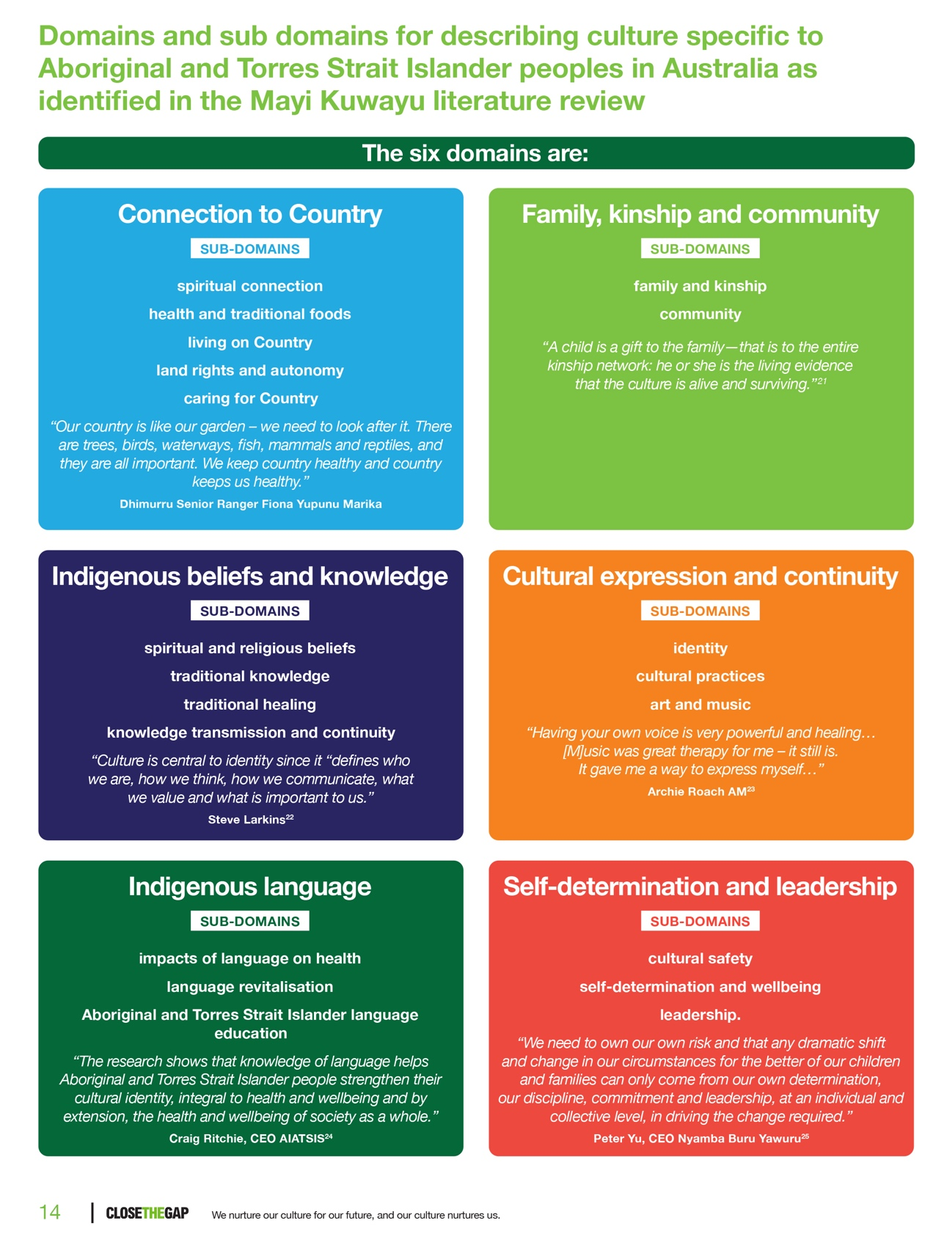Knowledge of these domains and sub-domains can support Western health services to deliver inclusive, holistic and culturally-informed models of care that meets the needs of First Nations Peoples and Communities.

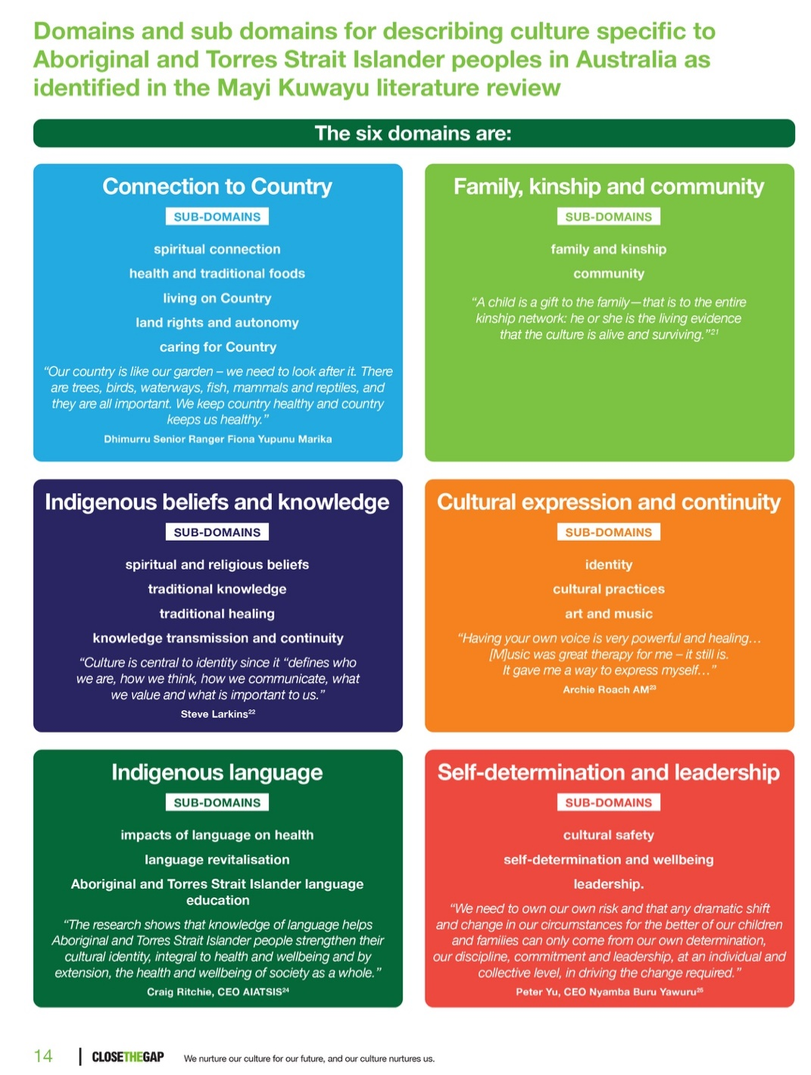

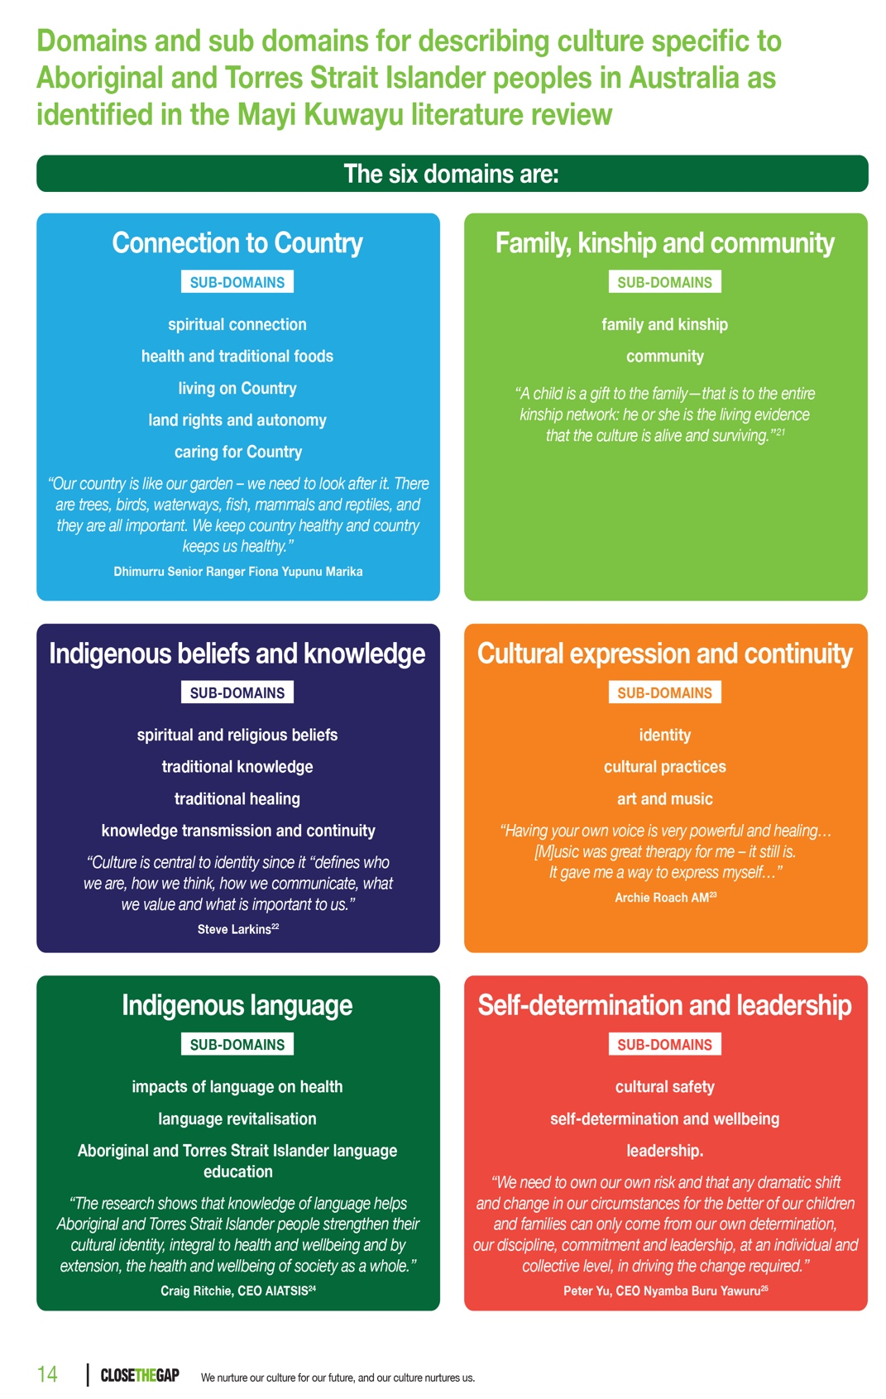

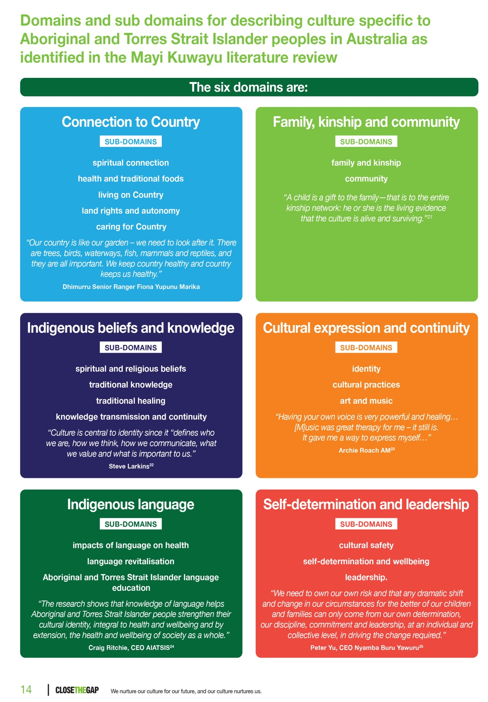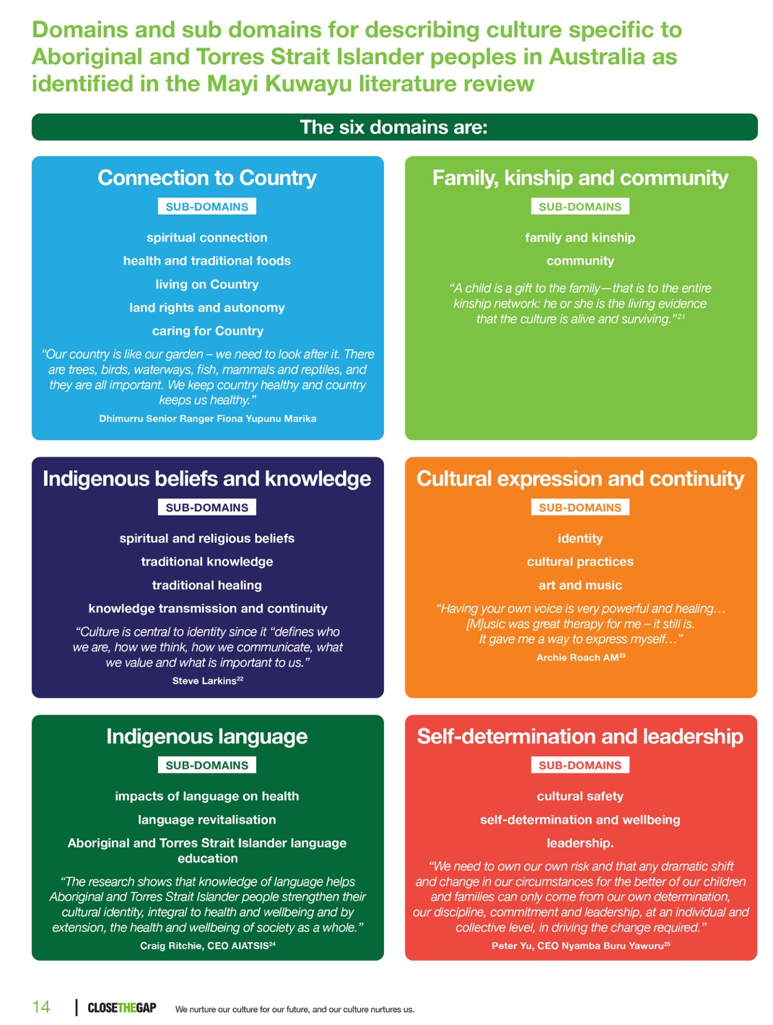

Lowitja Institute, 2020[4]

# Social and emotional wellbeing: An Aboriginal and Torres Strait Islander perspective

The National Aboriginal and Torres Strait Islander Health Plan 2021-2031 (Commonwealth of Australia, 2021) emphasises the critical need for social and emotional wellbeing approaches to health care and service delivery as follows:

**Priority 6:** Social and emotional wellbeing and trauma-aware, healing-informed approaches: Programs, policies and services prioritise social and emotional wellbeing through strengths-based approaches that embrace this holistic view and harness the protective factors of culture.

**Objective 6.4:** Implement training and other support across the whole health system to better understand and respond to social and emotional wellbeing in all aspects of life.

*The whole health system must be better equipped to provide trauma-aware and  
 healing-informed approaches. To enable this, training and other support must be more   
readily available for non-Indigenous and mainstream healthcare professionals to identify,   
understand and respond to Aboriginal and Torres Strait Islander social and emotional wellbeing. Mainstream health services and organisations delivering social and emotional wellbeing   
supports must forge partnerships with community-level organisations, including ACCHOs  
 to drive locally-relevant approaches and solutions (p.45).*

Providing culturally-informed, inclusive care to First Nations Peoples requires health services to respond to social and emotional wellbeing domains as shown in the following model.

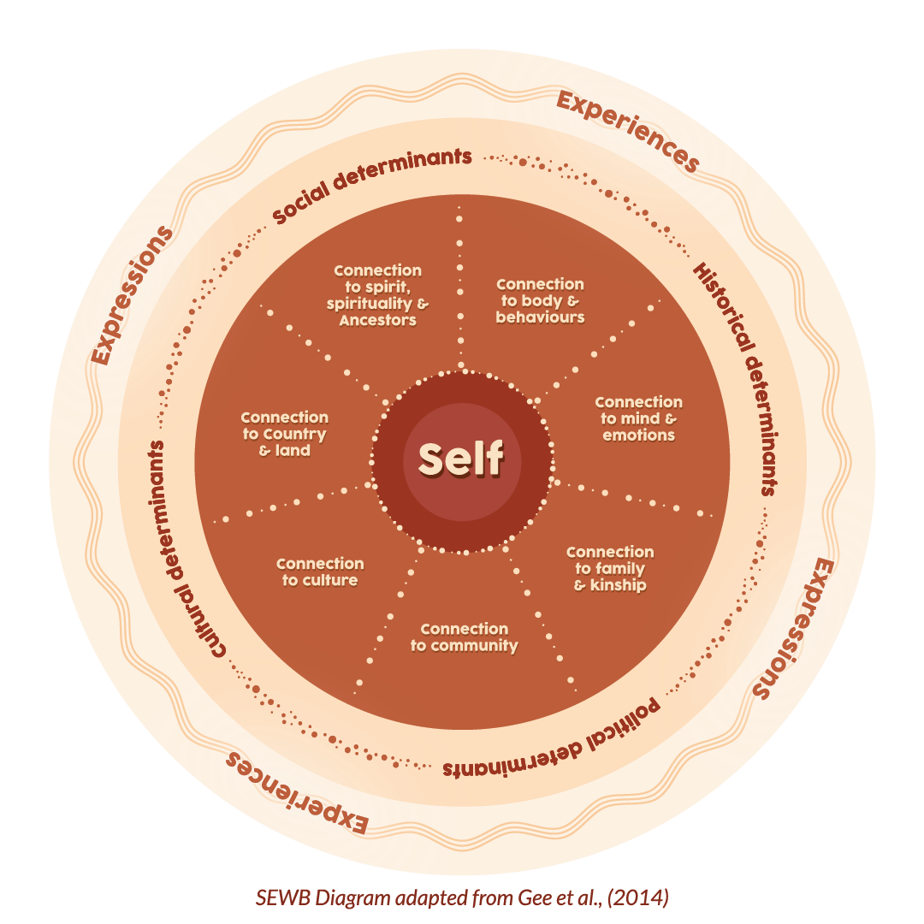

 Commonwealth of Australia, 2021[5]

Appendix B: Bibliography

The following is a list of the literature used to inform the development of Murray PHN’s Cultural Humility Framework and the User Guide.

Australian Commission on Safety and Quality in Health Care. (2021) National Safety and Quality Primary and Community Healthcare Standards. <https://www.safetyandquality.gov.au/sites/default/files/2021-10/national_safety_and_quality_primary_and_community_healthcare_standards.pdf>

Australian Commission on Safety and Quality in Health Care. (2022) National Safety and Quality Mental Health Standards for Community Managed Organisations. <https://www.safetyandquality.gov.au/sites/default/files/2022-11/nsqmh_standards_for_cmos_-_2022.pdf>

Australian Health Practitioners Regulation Agency [Ahpra] (2020) The National Scheme’s Aboriginal and Torres Strait Islander Health and Cultural Safety Strategy. <https://www.ahpra.gov.au/About-Ahpra/Aboriginal-and-Torres-Strait-Islander-Health-Strategy/health-and-cultural-safety-strategy.aspx>

Australian Health Practitioners Regulation Agency (2023) National Law Amendments <https://www.ahpra.gov.au/About-Ahpra/Ministerial-Directives-and-Communiques/National-Law-amendments.aspx#information-guide>

Australian Health Ministers’ Advisory Council’s National Aboriginal and Torres Strait Islander Health Standing Committee (2016) Cultural Respect Framework 2016-2026: For Aboriginal and Torres Strait Islander Health –   
A National approach to building a culturally respectful health system <https://nacchocommunique.com/wp-content/uploads/2016/12/cultural_respect_framework_1december2016_1.pdf>

Australian Institute of Health and Welfare (2023) Cultural Safety in health care for Indigenous Australians: monitoring framework. <https://www.aihw.gov.au/reports/indigenous-australians/cultural-safety-health-care-framework/contents/summary>

Australian National University and the Lowitja Institute (2019) Links between Aboriginal and Torres Strait Islander culture and wellbeing: what the evidence says. <https://mkstudy.com.au/wp-content/uploads/2019/06/MAK001_Links-between-culture_Brochure_A4-Online_FINAL_V6.pdf>

Coalition of Peaks (2020) Priority Reform Three. <https://coalitionofpeaks.org.au/wp-content/uploads/2020/11/Item-5-Priority-Reform-Indicator-Priority-Reform-3.pdf>

Commonwealth of Australia (2019) Actions to support older Aboriginal and Torres Strait Islander people A guide for aged care providers <https://www.health.gov.au/sites/default/files/documents/2019/12/actions-to-support-older-aboriginal-and-torres-strait-islander-people-a-guide-for-aged-care-providers.pdf>

Commonwealth of Australia, (2024). Framework for Governance of Indigenous Data: Practical guidance for the Australian Public Service. <https://www.niaa.gov.au/resource-centre/framework-governance-indigenous-data>

Commonwealth of Australia (2021) National Aboriginal and Torres Strait Islander Health Plan 2021-2031. <https://www.health.gov.au/resources/publications/national-aboriginal-and-torres-strait-islander-health-plan-2021-2031>

Commonwealth of Australia (2022) National Aboriginal and Torres Strait Islander Health Workforce Strategic Framework and Implementation Plan 2021–2031. <https://www.health.gov.au/sites/default/files/documents/2022/03/national-aboriginal-and-torres-strait-islander-health-workforce-strategic-framework-and-implementation-plan-2021-2031.pdf>

Commonwealth of Australia (2014) National Aboriginal and Torres Strait Islander Peoples’ Drug Strategy 2014 – 2019. <https://www.health.gov.au/sites/default/files/national-aboriginal-and-torres-strait-islander-peoples-drug-strategy-2014-2019_0.pdf>

Commonwealth of Australia (2020) National Agreement on Closing the Gap. <https://www.closingthegap.gov.au/sites/default/files/files/national-agreement-ctg.pdf>

Commonwealth of Australia (2017) National Strategic Framework for Aboriginal and Torres Strait Islander Peoples’ Mental Health and Social and Emotional Wellbeing 2017-2023. <https://www.niaa.gov.au/sites/default/files/documents/publications/mhsewb-framework_0.pdf>

Commonwealth of Australia (2016) National Framework for Health Services for Aboriginal and Torres Strait Islander Children and Families. <https://nacchocommunique.com/wp-content/uploads/2016/12/national-framework-for-health-services-for-aboriginal-and-torres-strait-islander-children-and-families.pdf>

Department of Health and Aged Care (2019) Revised Aged Care Quality Standards Detailed version for public consultation. <https://www.health.gov.au/sites/default/files/documents/2022/10/revised-aged-care-quality-standards-detailed-draft-for-public-consultation-revised-aged-care-quality-standards-detailed-draft-for-public-consultation.pdf>

Diversity Council Australia/Jumbunna Institute (Brown, C., D’Almada-Remedios, R., Gilbert, J. O’Leary, J. and Young, N.) Gari Yala (Speak the Truth): Centreing the Work Experiences of Aboriginal and/or Torres Strait Islander Australians, Sydney, Diversity Council Australia/Jumbunna Institute, 2020. <https://www.dca.org.au/research/project/gari-yala-speak-truth-centreing-experiences-aboriginal-andor-torres-strait-islander>

Gayaa Dhuwi (Proud Spirit) Australia (2015) Gayaa Dhuwi (Proud Spirit) Declaration. <https://www.gayaadhuwi.org.au/wp-content/uploads/2022/09/WEB_gayaa_dhuwi_declaration_A4-2.pdf>

Indigenous Allied Health Australia (2019) Cultural Responsiveness in Action: An IAHA Framework. <https://iaha.com.au/wp-content/uploads/2020/08/IAHA_Cultural-Responsiveness_2019_FINAL_V5.pdf>

Lowitja Institute (2020) Culture is Key: Towards cultural determinants-driven health policy <https://www.lowitja.org.au/wp-content/uploads/2023/06/Lowitja_CultDetReport_210421_D14_WEB.pdf>

Lowitja Institute (2020), Close the Gap: We nurture our culture for our future, and our culture nurtures us, Close The Gap Campaign, Sydney. <https://www.lowitja.org.au/wp-content/uploads/2023/05/CtG2020_FINAL4_WEB-1.pdf>

National Aboriginal Health Strategy Working Party. (1989). A National Aboriginal Health Strategy. Canberra: Australian Government Publishing Services. <https://webarchive.nla.gov.au/awa/20090918084409/http://www.aboriginalandtorresstraitislanderhealthawards.gov.au/internet/main/publishing.nsf/Content/health-oatsih-pubs-NAHS1998>

Royal Australian College of General Practitioners (2020) Standards for general practices. 5th edn. East Melbourne, Vic: Royal Australian College of General Practitioners. <https://www.racgp.org.au/getattachment/ece472a7-9a15-4441-b8e5-be892d4ffd77/Standards-for-general-practices-5th-edition.aspx>

Royal Australian College of General Practitioners (2024) NACCHO RACGP Good Practice Tables <https://www.racgp.org.au/the-racgp/faculties/aboriginal-and-torres-strait-islander-health/guides/naccho-racgp-good-practice-tables>

State of Victoria, Australia, Department of Health and Human Services (2021) Aboriginal and Torres Strait Islander cultural safety framework. <https://www.health.vic.gov.au/publications/aboriginal-and-torres-strait-islander-cultural-safety-framework-part-1>

State of Victoria, Australia, Department of Health and Human Services (2021) Aboriginal and Torres Strait Islander cultural safety framework – Cultural safety continuum reflective tool <https://www.health.vic.gov.au/publications/aboriginal-and-torres-strait-islander-cultural-safety-framework-part-1>

State of Victoria, Australia, Department of Health and Human Services (2020) Improving Care for Aboriginal Patients (ICAP) program guidelines <https://www.health.vic.gov.au/publications/improving-care-for-aboriginal-patients-program-guidelines>

State of Victoria, Australia, Department of Health and Human Services (2022) Aboriginal cultural safety fixed grant requirements Cultural safety planning and reporting. <https://www.health.vic.gov.au/publications/aboriginal-cultural-safety-fixed-grant-guidelines-cultural-safety-planning-and>

State of Victoria, Australia, Department of Health and Human Services, (2017) Korin Korin Balit-Djak system transformation: Aboriginal health, wellbeing and safety strategic plan 2017-2027 <https://www.dffh.vic.gov.au/sites/default/files/documents/202302/korin-korin-balit-djak.pdf>

State of Victoria, Australia, Department of Health and Department of Families, Fairness and Housing, September (2021) Aboriginal workforce strategy 2021 – 2026. <https://www.dffh.vic.gov.au/sites/default/files/documents/202109/DH%20and%20DFFH%20Aboriginal%20Workforce%20Strategy%202021%E2%80%932026%20v2.pdf>

Wardliparingga Aboriginal Research Unit (2017) National Safety and Quality Health Service Standards user guide for Aboriginal and Torres Strait Islander health. Sydney: Australian Commission on Safety and Quality in Health Care. <https://www.safetyandquality.gov.au/sites/default/files/migrated/National-Safety-and-Quality-Health-Service-Standards-User-Guide-for-Aboriginal-and-Torres-Strait-Islander-Health.pdf>

1. Commonwealth of Australia (2020) National Agreement on Closing the Gap. <https://www.closingthegap.gov.au/sites/default/files/files/national-agreement-ctg.pdf>
2. Commonwealth of Australia, (2024). Framework for Governance of Indigenous Data: Practical guidance for the Australian Public Service. <https://www.niaa.gov.au/resource-centre/framework-governance-indigenous-data>
3. Commonwealth of Australia, (2024). Framework for Governance of Indigenous Data: Practical guidance for the Australian Public Service. <https://www.niaa.gov.au/resource-centre/framework-governance-indigenous-data> See CHF User Guide
4. Lowitja Institute (2020), Close the Gap: We nurture our culture for our future, and our culture nurtures us, Close The Gap Campaign, Sydney. <https://www.lowitja.org.au/wp-content/uploads/2023/05/CtG2020_FINAL4_WEB-1.pdf>
5. Commonwealth of Australia (2021) National Aboriginal and Torres Strait Islander Health Plan 2021-2031. <https://www.health.gov.au/resources/publications/national-aboriginal-and-torres-strait-islander-health-plan-2021-2031>